Mobile Application Host Platform

It was decided that using a mobile smart phone application would easily enable the user to sketch their picture, which would then be wirelessly transferred to the car allowing it to draw the illustration. The two types of mobile applications are native applications and web applications. Web applications are based on websites designed especially for mobile phones, this means that any mobile phone with a modern browser can use these applications, however not all the devices functionality is accessible. On the other hand native applications have to be written for each platform you wish to support, but can use all of the functionality available on that device.

Communication Method

In order to communicate between the mobile application and the car a channel had to be decided, the two main techniques used for short range wireless communication are Bluetooth and Wi-Fi. The Bluetooth would directly link from the mobile application to car which would include a Bluetooth receiver. Where, using Wi-Fi would mean proving a Wi-Fi transceiver for a secondary microcontroller on the car. Which would run a simple web server to interrupt commands received from clients connected to the web site. This would provide a fair bit of additional functionality such as multiple connected users and access from any internet device. However since it was decided this functionality would not be required since only one person would be using the car at any one time and most likely it would only be used from a mobile device due to the portable nature of the car.

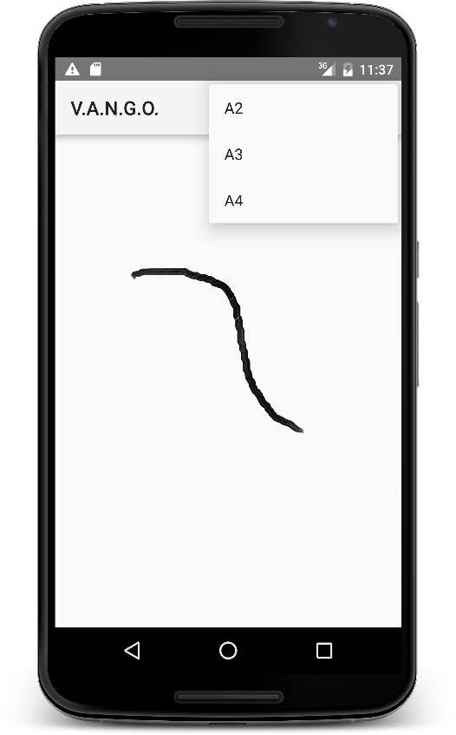This lead to the decision to use a Bluetooth connection. Which meant that we required to use a native mobile application as opposed to a web application. Since at the time of research web applications do not have access to most devices Bluetooth functionality, without creating a wrapper application. This caused us to decide to develop an Android application since Android represents the majority share of the UK market at roughly 81.1% ROSS_REF_1]. Furthermore the Android development environment is freely available to any user and is operating system independent, whereas the second largest mobile application platform in the UK market, iOS can only be developed using Mac OSX. The android application will be written using Java and the Android Development Studio which are both available for free download.

Figure ROSSFIGUREONE : Preliminary App Design

User Drawn Line

Canvas

Page Size Selector

As shown above in figure ROSSFIGUREONE, the mobile application would mostly be populated by the drawing canvas, where the user can draw the image they want to be printed. The application will also feature a drop down menu which will allow the user to select which size of paper they wish their image to be printed upon.

[ROSS_REF_1] - <http://uk.businessinsider.com/idc-global-smartphone-sales-slow-android-81-share-2019-iphone-2015-8> [October 8th 2015]